ideation
A.Y 2022-23(Odd Sem) Date:

Report on PSR Activity: Super AI Community Stakeholder Connect

Objective:
The objective of Super AI Community Stakeholder Connect is to build students’ knowledge, skill and strengthen the domain by inclusion of Industry Academia/ Alumni expert sessions/ Peers Learning Sessions, competitions, exhibitions and collaborative research activities.
Following activities are done during Academic Year 2022-23 Odd Semester:
Activity 1: Session on Roadmap to Machine Learning
Date: 7th October 2022
Time: 2.30pm to 4.30pm

Participants: ST and TT students

Objectives:

- To provide the students a roadmap for Machine Learning.
- To help the students clear their doubts about their branch and the steps they need to follow.

Description:
A Session on Roadmap to Machine Learning was conducted by Dr Megharani Patil, I/C HOD AI&ML. Dr Megharani Patil, I/C HOD AI&ML briefed students about the roadmap to Machine Learning, the prerequisites required ,tools and technologies to be learned to become industry ready.

Participation Analysis:
Sr. No. | Class | No. of Students
1 | ST | 49
2 | TT | 55

Outcome:
Students were able to understand the importance of sharpening their skills and learning tools and technologies required by the industry.

Activity 2: Peer Learning session on”DSA and Competitive Programming”
Date: 11th October 2022
Time: 2.30pm to 4.30pm

Participants: ST and TT Students

Objectives:
- To facilitate creative thinking in students.
- To create awareness of competitive programming platforms.
- To provide knowledge about Data Structure concepts.

Description:

A Peer learning Session on”DSA and Competitive Programming” was conducted by Jwala Chorasiya,Student,TT(V Sem) . He guided the students about various programming platforms such as CodeChef and also gave insights about some important concepts of DSA and how to implement them.

Participation Analysis:
Sr. No. | Class | No. of Students
1 | ST | 49
2 | TT | 06
Total : |  | 55

Activity Photo:

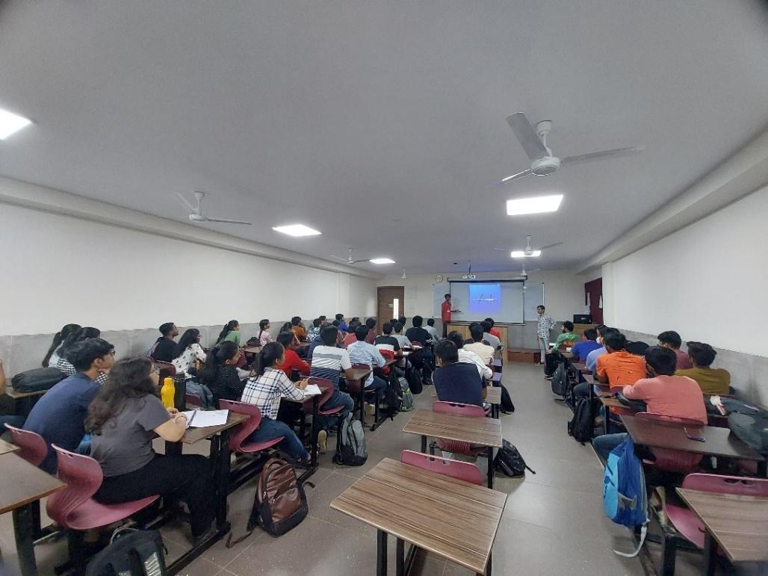

Feedback Analysis:
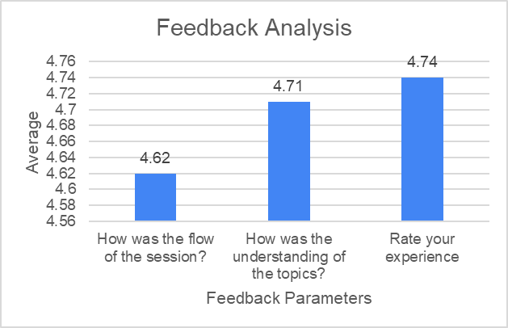

Outcome:

Students were able to understand the importance of DSA and Competitive Programming and explored various platforms to practice Competitive Programming.

Activity 3: Poster Making Competition of AI&ML Domains
Date: 28th October 2022

Participants: ST and TT Students

Objectives:

- To facilitate creative thinking in students.
- To extend their research and thinking capabilities to higher levels.

Participation Analysis:
Sr. No. | Class | No. of Students
1 | ST | 05
2 | TT | 03
Total : |  | 08

Description:

A Poster Making Competition was organized in online mode. Students were given one week time to create their posters (Digital or Hand-drawn). Student’s intellectual and creative posters showed their level of understanding of the Domain..
Following are the domains given for Poster Making Competition:
1.Health Care
2.Agritech
3.AI&ML in security
4.Education
5.Applications related to Social Benefits

Activity Photo:

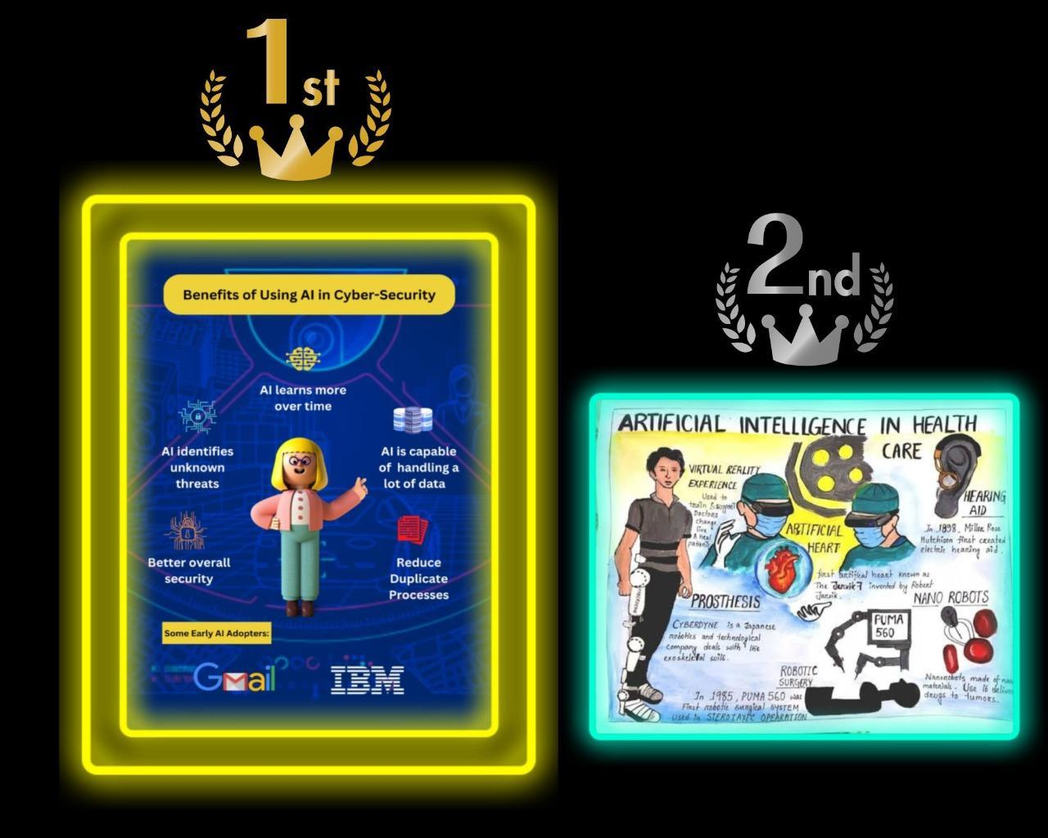

Outcome:

Students were able to portray their perspectives of the domain in a creative way and hence found the activity very interesting.

Activity 4: Online Session on “Prerequisites to deep learning” by industry expert and alumni of Computer Engineering Department
Date: 29th October, 2022
Time: 11.00am to 1.00pm

Participants: ST & TT Students

Objectives:
- To help students get an idea of what Deep Learning is and its prerequisites.
- To give them a fundamental idea of their field.
- To help the students to get their doubts cleared by an industry expert.

Description:

A Pre-requisites to deep learning session was organized in online mode, by Mr. Devrath Singh Bisht,Software Engineer at JP Morgan Chase&Co,Alumini of Computer Engineering Department. He taught some basic statistics and fundamentals of Deep learning by referring to some use cases of Deep Learning.

Participation Analysis:
Sr. No. | Class | No. of Students
1 | ST | 23
2 | TT | 19
Total : |  | 48

Activity Photo:

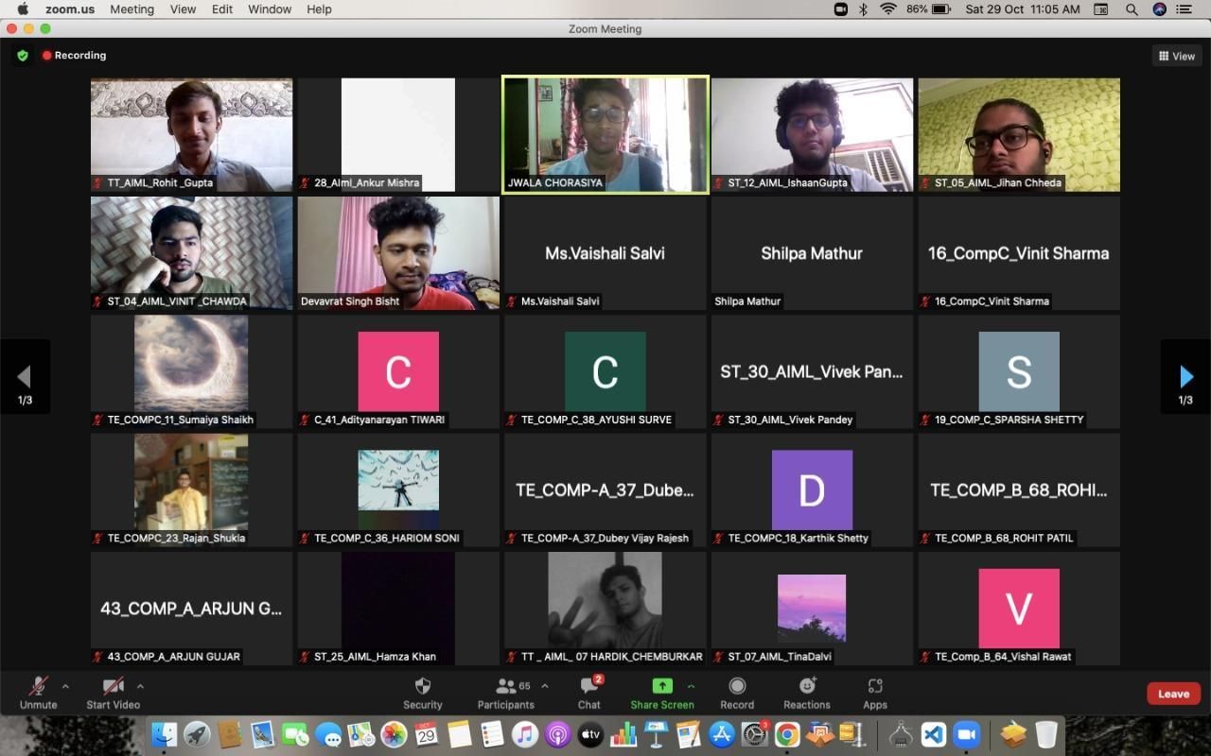

Feedback Analysis:
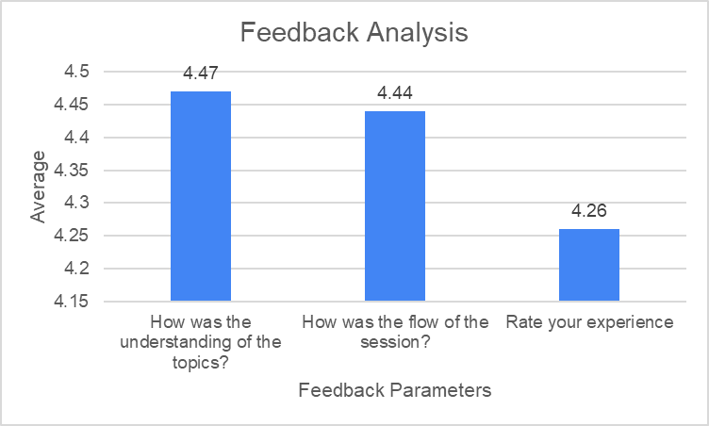

Outcome:

Students were able to understand Deep Learning concepts , tools and pre-requisites required and were able to gain clarity on the same.
Activity 5: Coding Competition
Date: 12th November 2022
Time: 2.30pm to 4.30pm
Platform: HackerEarth

Participants: ST and TT Students

Objectives:

- To facilitate objective thinking in students.
- To introduce and inculcate the habit of Coding.
- To extend their research and thinking capabilities to higher levels.

Description:

A Coding competition was organized in online mode. Students were given two hours to solve 4 questions. Questions on following Subject Areas were asked:
1.Array
2.Data Structures
3.Algorithms

Participation Analysis:
Sr. No. | Class | No. of Students
1 | ST | 21
2 | TT | 12
Total : |  | 33

Feedback Analysis:
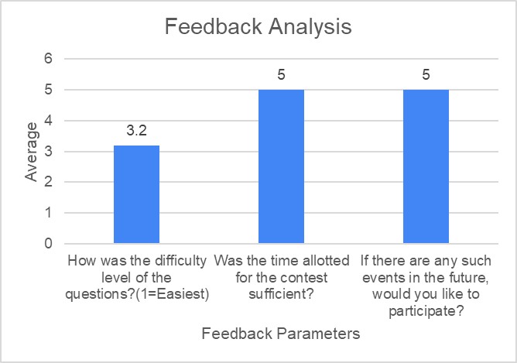

Outcome:

Students were able to use their logical thinking and knowledge to implement the code.

Activity 6: Peer Learning session on “Career Guidance”
Date:28/12/2022
Time: 4.30pm to 5.30pm

Participants: FT Students

Objectives:
- To create awareness about various career options.
- To give them a better understanding of the job market and different industries.

Description:

A Peer learning Session on” Career Guidance” was conducted by Jwala Chorasiya,Student,TT(V Sem) . He guided the students about various career options.

Participation Analysis:
Sr. No. | Class | No. of Students
1 | FT | 54

Activity Photo:
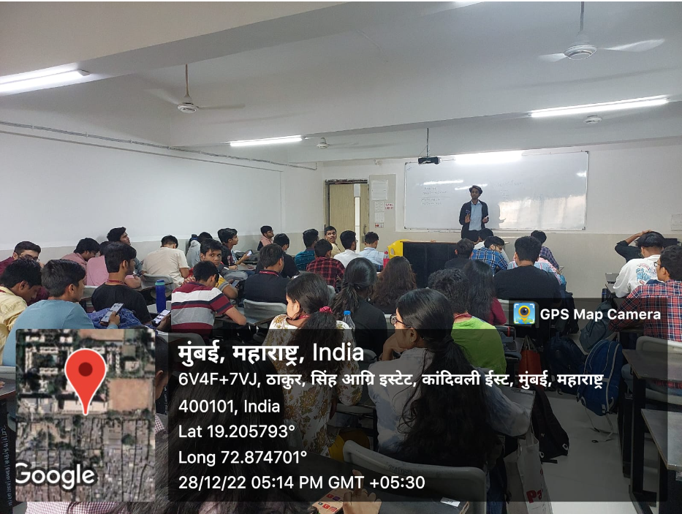
Feedback Analysis:
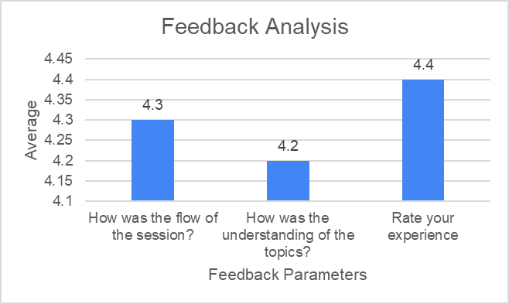

Outcome:

Students were able to get clarity on career goals and steps to achieve them.

Prepared By
Mrs Shilpa Mathur Dr.Megharani Patil
Faculty Coordinator Convener
Assistant Professor AI&ML I/C HOD AI&ML

